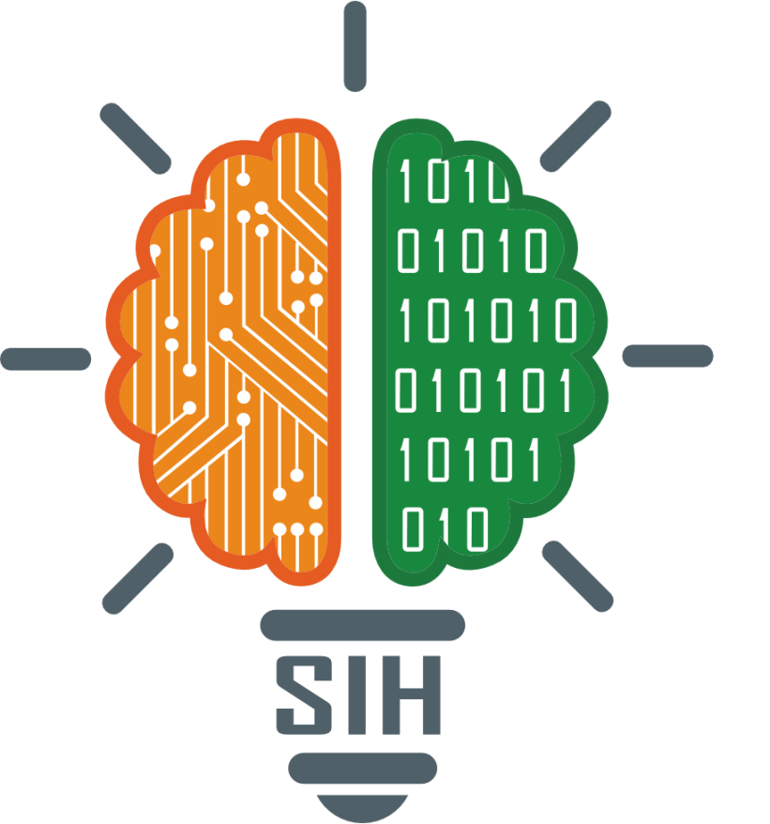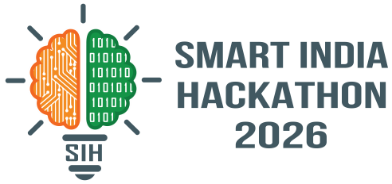SMART INDIA HACKATHON 2026
- Problem Statement ID –26094
- Problem Statement Title-
- AI-Powered Dynamic Mental Health Monitoring and Distress Prediction System for Victims of Atrocities
- Theme-
- MedTech/BioTech/ HealthTech
- PS Category- Software

- Team ID-

- Team Name - Esoteric

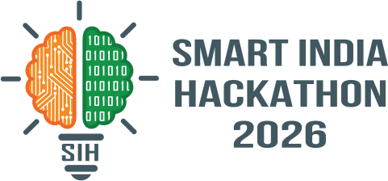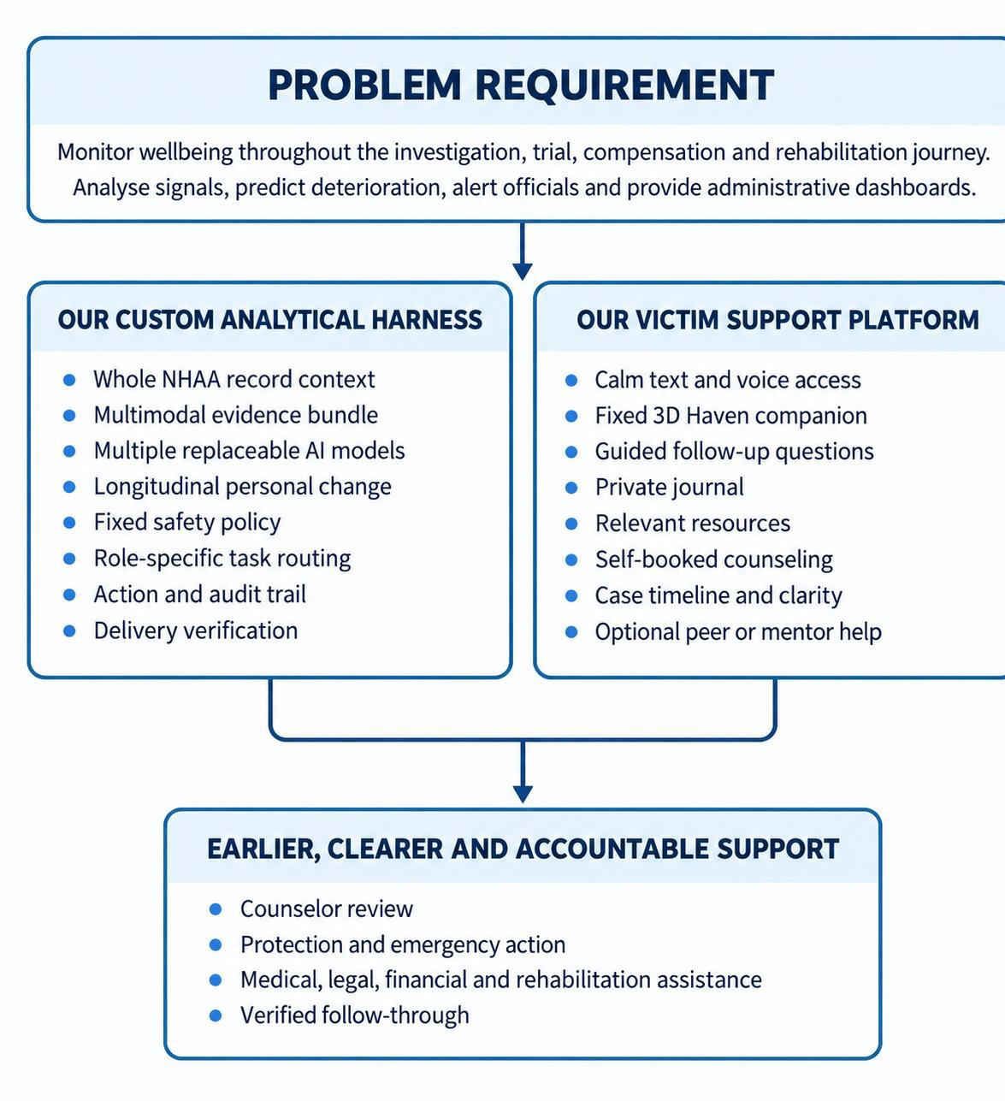Haven: Dynamic mental health monitoring and distress response for victims of atrocities

Esoteric
- Proposed Solution:
- Haven combines a custom evidence-to-action harness with a victim facing platform designed for calm, clarity and continued support with the inclusion of base we display our contribution to the existing solutions
- How it addresses the problem

Purpose-built analytical harness:

Multiple replaceable language, speech, translation and scoring models
work through one governed evidence pipeline.

Victim-first support environment
  - The platform encourages continued engagement through a calm text and speech-to-speech interface 3D Haven companion, private journaling, relevant resources, case clarity, self-booked counselling and
supervised peer support.

Separate human workflows
  - Counsellors receive mental-health evidence. Authorities receive
only the protection, relief, legal or rehabilitation information needed for their task

Understands the wider stress context:
  - Considers threats, intimidation, repeated hearings, delays, economic hardship, social isolation and rehabilitation
barriers alongside mental-health signals.

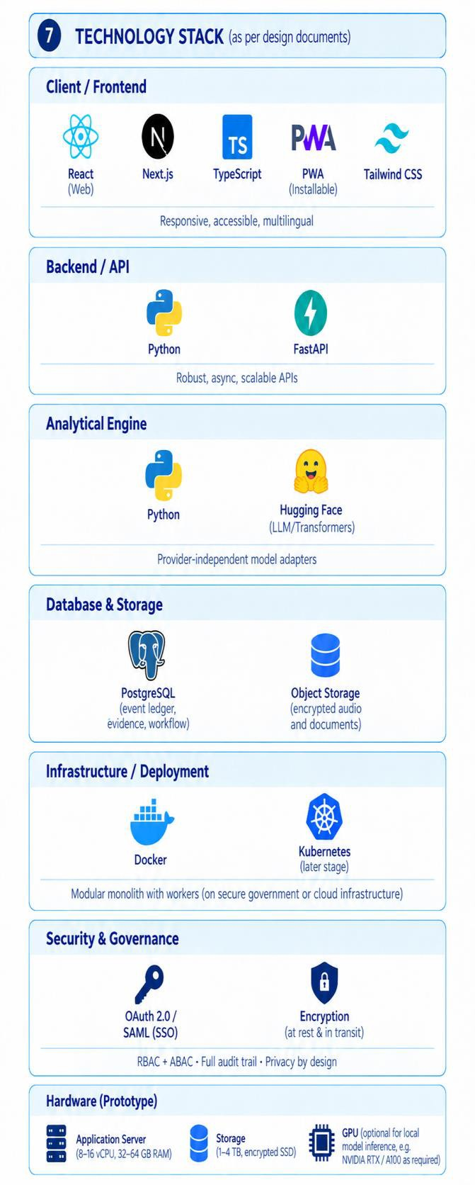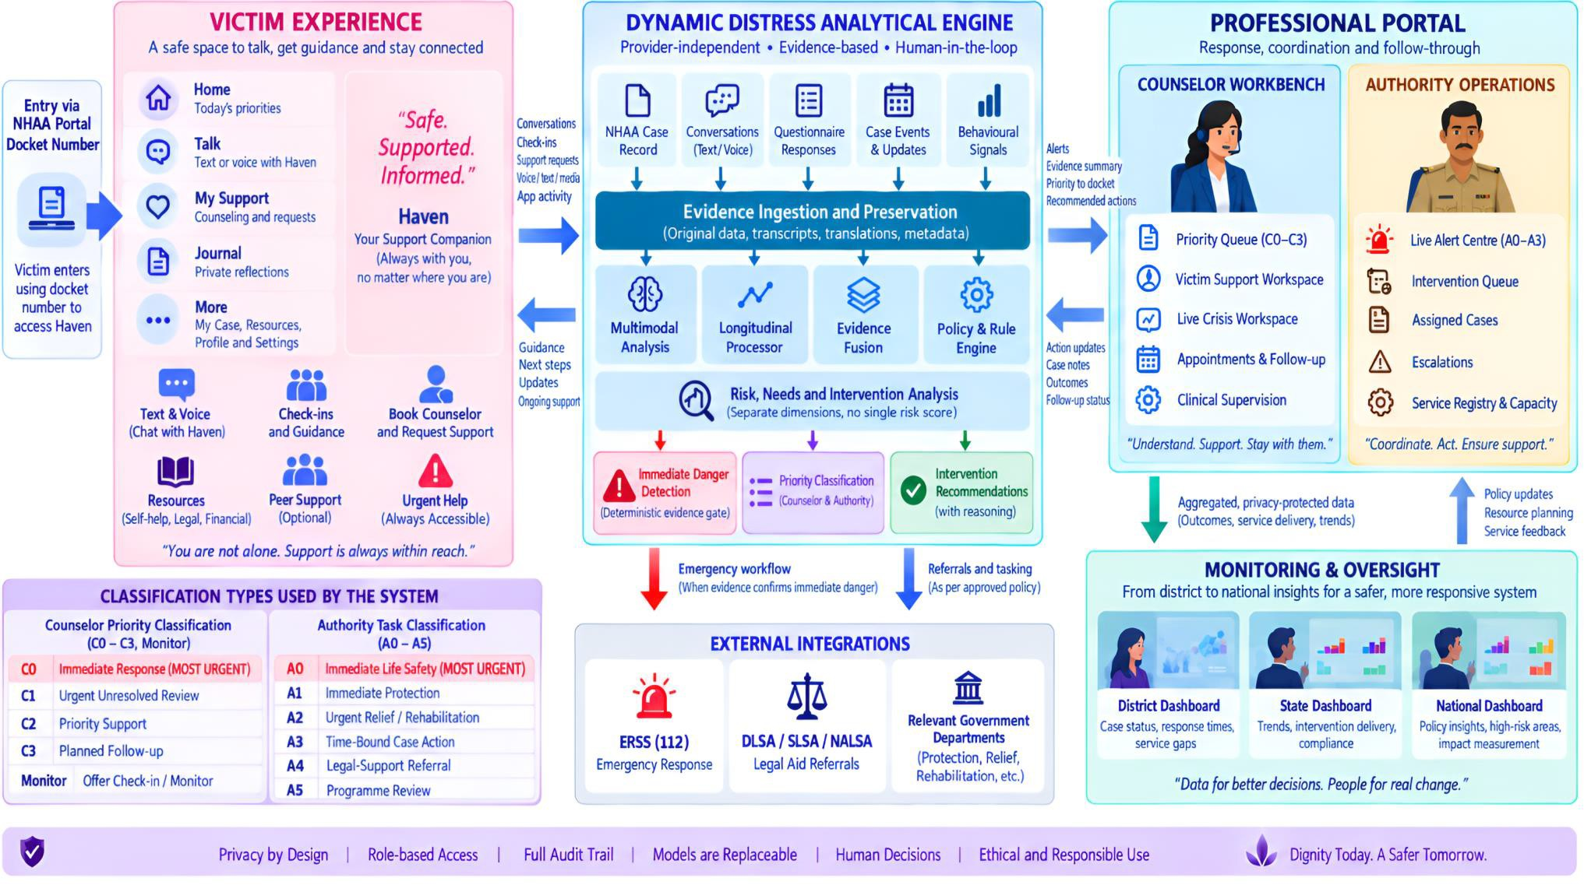
Esoteric

TECHNICAL APPROACH

Data exposure
Role-scoped fields and audit logs
Language variation
Per-language and channel validation
No historical labels
Prospective human-reviewed evidence
Alert fatigue
Deadlines, acknowledgement and escalation

Feasibility and viability

Esoteric

Staged deployment
1 Establish Case ingestion, rules,
questionnaires, counselor
queue and authority tasks
2 Expand Multilingual text, speech
evidence and shadow
evaluation

3 Connect Approved NHAA, district, legal
and emergency connectors
4 Validate Predictive support models
after representative reviewed
data exists


Control is added at each step; deployment does not depend on trusting one model.
Wrong alert
Evidence spans and timeframe checks
- The system becomes viable when NHAA, counselors, district officials, emergency responders and service providers agree on:
  - Their responsibilities.
  - What information each role may see.
  - Who can contact the victim.
  - Who can approve an intervention.
  - Who can close a task.
  - What happens when nobody responds.
  - How records are retained and corrected.
  - How official integrations operate.

Risks and design controls
Viability

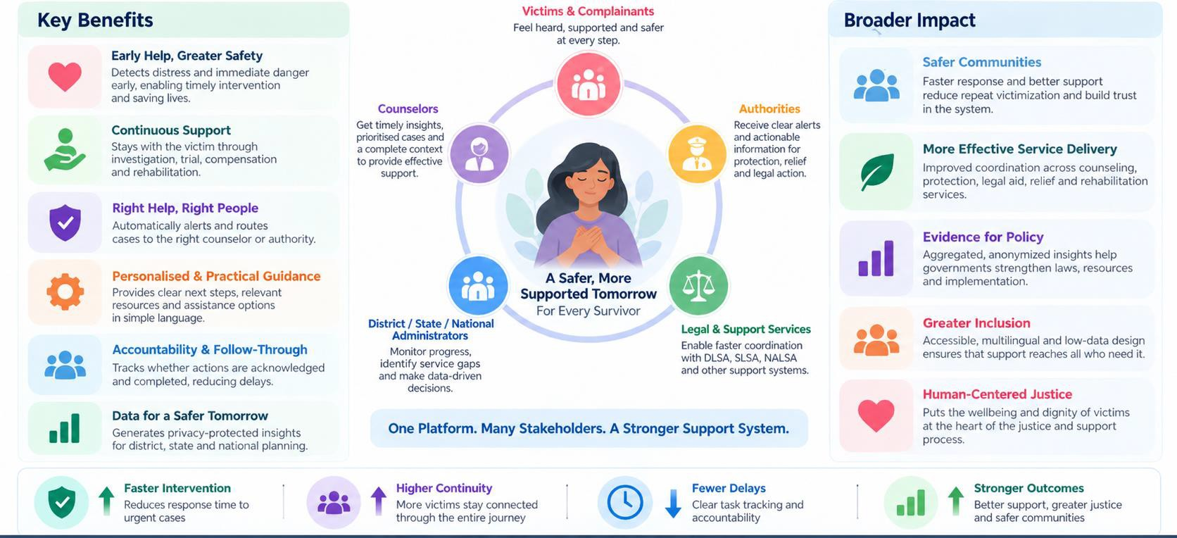

Impact and benefits

Esoteric

RESEARCH AND REFERENCES

Esoteric

RESEARCH AND REFERENCES
  - Government and statutory foundation
  - • National Helpline Against Atrocities (NHAA) Portal and Ministry of Social Justice Annual Report 2025–26
  - • SC/ST (Prevention of Atrocities) Act, 1989, especially Section 15A
  - • SC/ST Prevention of Atrocities Rules, 1995 and 2016–18 amendments

Mental-health support and emergency pathways
  - • WHO Psychological First Aid
  - • NIMH Adult Suicide Safety Assessment Toolkit
  - • Tele-MANAS Operational Guidelines
  - • Emergency Response Support System 112

Responsible analytical design
  - • NICE NG225 guidance on avoiding global suicide-risk prediction scales
  - • WHO Ethics and Governance of Artificial Intelligence for Health
  - • NIST AI Risk Management Framework
  - • Digital Personal Data Protection Act and Rules, 2025

Measurement, multilingual AI and inclusive access
  - • WHO-5, PHQ-9, GAD-7 and PCL-5 measurement guidance
  - • EmoBox and SER-Evals multilingual speech-emotion benchmarks
  - • W3C Web Content Accessibility Guidelines 2.2
  - • SAMHSA Core Competencies for Peer Support Workers

Source links:

nhapoa.gov.in/en socialjustice.gov.in indiacode.nic.in
112.gov.in mohfw.gov.in who.int
nimh.nih.gov nice.org.uk nist.gov
meity.gov.in
isca-archive.org samhsa.gov

